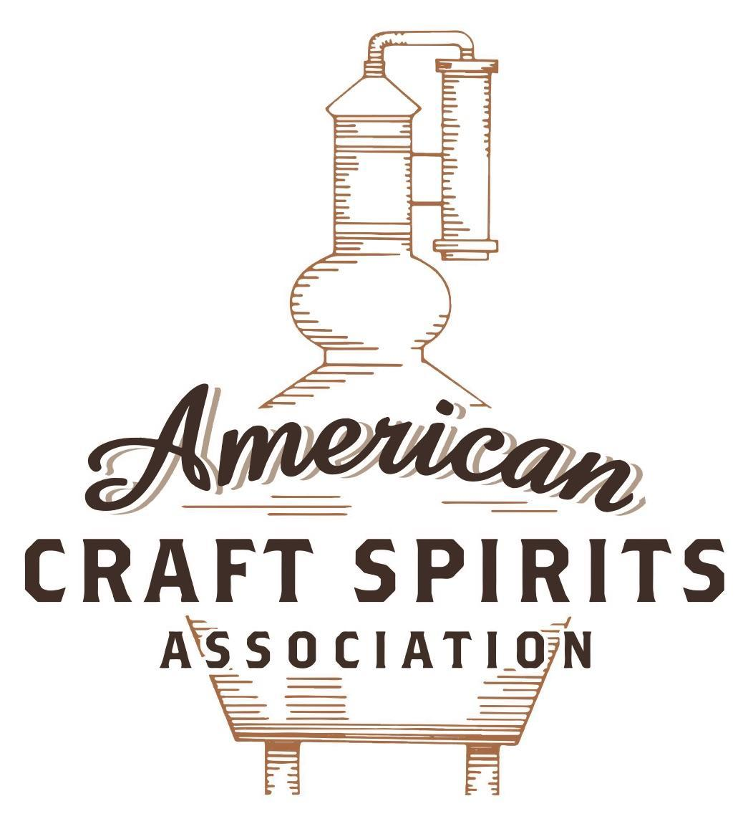
Spirits DtC Shipping Guide

This guide summarizes the direct-to-consumer shipping rules for distilleries in all 50 states and D.C. and also addresses the measures state governments have taken to ease delivery and shipping restrictions during the COVID-19 pandemic.

DtC Quick Guide Comparison

Out-of-State Distilleries  Can Ship Into State? |  |  |  | In-State Distilleries  Can Ship Within State?
State | Yes | No |  | State | Yes | No
AL |  | X |  | AL |  | X
AK | X |  |  | AK | X
AZ | X |  |  | AZ | X
AR |  | X |  | AR |  | X
CA |  | X* |  | CA |  | X*
CO |  | X |  | CO |  | X
CT |  | X* |  | CT |  | X
DE |  | X |  | DE |  | X
DC | X |  |  | DC | X
FL |  | X |  | FL |  | X
GA |  | X |  | GA |  | X
HI |  | X* |  | HI |  | ?*
ID |  | X |  | ID |  | X
IL |  | X* |  | IL |  | X*
IN |  | X |  | IN |  | X
IA |  | X* |  | IA |  | X*
KS |  | X |  | KS |  | X
KY | X |  |  | KY | X
LA |  | X |  | LA |  | X
ME |  | X* |  | ME |  | X*
MD |  | X |  | MD |  | X
MA |  | X |  | MA |  | X
MI |  | X |  | MI |  | X
MN |  | X |  | MN |  | X
MS |  | X |  | MS |  | X
MO |  | X |  | MO |  | X
MT |  | X |  | MT |  | X
NE | X |  |  | NE | X
NV |  | X* |  | NV |  | X
NH | X |  |  | NH |  | X*
NJ |  | X* |  | NJ |  | X*
NM |  | X |  | NM |  | X
NY |  | X* |  | NY |  | X*
NC |  | X |  | NC |  | X
ND | X |  |  | ND | X
OH |  | X |  | OH |  | X
OK |  | X |  | OK |  | X
OR |  | X |  | OR | X
PA |  | X* |  | PA |  | X
RI |  | X* |  | RI |  | X
SC |  | X |  | SC |  | X
SD |  | X |  | SD |  | X
TN |  | X |  | TN |  | X
TX |  | X |  | TX |  | X
UT |  | X |  | UT |  | X
VT |  | X |  | VT |  | X
VA |  | X |  | VA |  | X
WA |  | X* |  | WA | X
WV |  | X* |  | WV |  | X*

WI |  | X |  | WI |  | X
WY |  | X |  | WY |  | X

Notes:
*CA: If passed and signed into law, Senate Bill 620 would allow licensed distilled spirits producers in states other than California and licensed distilled spirits manufacturers or craft distillers in California who obtain distilled spirits direct shipper permits to ship directly to consumers in California
*CT: Consumers with appropriate permit may receive alcohol shipments
*HI: Consumers with appropriate permit may receive alcohol shipments; If passed and signed into law, Senate Bill 65 would allow licensed distilled spirits manufacturers in Hawaii and in states other than Hawaii who obtain direct shipper permits to ship directly to consumers in Hawaii
*IL: If passed and signed into law, Senate Bill 0532 would allow licensed distilled spirits producers in Illinois and in states other than Illinois who obtain distillery shippers’ licenses to ship directly to consumers in Illinois
*IA: If passed and signed into law, House File 639 would allow native distilled spirits manufacturers in Iowa and in states other than Iowa who obtain direct shipper permits to ship directly to consumers in Iowa and to consumers in states other than Iowa
*ME: If passed and signed into law, Legislative Document 1358 would allow distilleries outside of Maine with current manufacturer licenses and distilleries licensed in Maine who obtain spirits direct shipper licenses to ship directly to consumers in Maine
*NJ: (1) If passed and signed into law, Assembly Bill 3167 would allow a craft distillery licensees to ship no more than 9 liters of distilled spirits to a consumer in New Jersey; (2) If passed and signed into law, Senate Bill 3020 would allow craft distillery licensees in New Jersey or in states other than New Jersey to ship no more than 20 liters of distilled spirits to a consumer in New Jersey via common carrier
*NV: Licensed individuals can import one gallon per month of spirits for personal use and the out-of-state supplier must pay excise tax
*NH: If passed and signed into law, Senate Bill 125 would allow licensed liquor manufacturers who obtain direct to consumer shipping permits from the commission to ship directly to consumers in New Hampshire
*NY: Consumer may import up to 90L of liquor per year for personal use without a license; If passed and signed into law, Assembly Bill 3275 would allow licensed liquor manufacturers in states other than New York and licensed distillers and farm distillers in New York to ship no more than thirty-six cases (no more than nine liters per case) of liquor to consumers in New York
*PA: Consumer may place a special liquor order and distiller must ship to a PLCB-operated store
*RI: Distiller can only ship to customer if order was personally placed by customer at distiller's premises
*WA: If passed and signed into law, House Bill 1432 would allow licensed spirits manufacturers in states other than Washington to ship spirits to consumers in Washington
*WV: Distilleries, mini-distilleries, or micro-distilleries licensed in West Virginia or a state other than West Virginia who obtain private direct shipper licenses to ship to a consumer in West Virginia, however the shipments must be made to a retail liquor outlet

WISCONSIN
Shipment Outbound – Silent. However, the legislative intent of Wisconsin’s alcohol laws states that face-to-face retail sales at licensed premises directly advance the state's interest in preventing alcohol sales to underage or intoxicated persons and the state's interest in efficient and effective collection of tax, so Wisconsin authorities could point to the legislative intent of the chapter to prohibit outbound sales, unless the purchase is made at the distiller’s premises (Wis. Stat. § 125.01).
Shipment Inbound – No, out-of-state shippers must ship to WI wholesalers, manufacturers, rectifiers or wineries. (Wis. Stat. § 125.58(1)).
Shipment Intra-state – No, manufacturers must ship to WI wholesalers, manufacturers, rectifiers or wineries. Manufacturers may also sell their product to consumers at their premises, for consumption on or off the premises (Wis. Stat. § 125.52(1)(b)(1); (2)).
COVID-19 Measures – The guidelines related to COVID-19 state that distilleries may sell alcohol beverages in original, sealed containers on a "carry-out" basis only, and only where permitted by municipal ordinance. All sales of alcohol beverages must occur in a face-to-face transaction.
Citation (shipment)
Wisconsin Statutes
§ 125.01 Legislative intent.
It is further the intent of the legislature that without a specific statutory exception, all sales of alcohol beverages shall occur through the 3-tier system, from manufacturers to wholesalers holding a permit to retailers to consumers. Face-to-face retail sales at licensed premises directly advance the state's interest in preventing alcohol sales to underage or intoxicated persons and the state's interest in efficient and effective collection of tax.
Link: https://docs.legis.wisconsin.gov/statutes/statutes/125/i/01
§ 125.52 Manufacturers' and rectifiers' permits.
(1) Authorized activities.
(b)
1. A manufacturer's or rectifier's permit entitles the permittee to sell intoxicating liquor to wholesalers holding a permit under s. 125.54, to wineries holding a permit under s. 125.53, and to other manufacturers and rectifiers holding a permit under this section, from the premises described in the permit. Except as provided in subd. 2., no sales may be made for consumption on the premises of the permittee.
2. Notwithstanding s. 125.09 (1), a manufacturer's or rectifier's permit authorizes the retail sale of intoxicating liquor that is manufactured or rectified on the premises, for consumption on or off the premises. A manufacturer's or rectifier's permit also authorizes the provision of taste samples, free of charge and in an amount not exceeding a total of 1.5 fluid ounces to any one person, of intoxicating liquor that is manufactured or rectified on the premises, for consumption on the premises. The department may prescribe additional regulations for the sale of intoxicating liquor under this subdivision, if the additional regulations do not conflict with the requirements applicable to holders of “Class B" licenses. Notwithstanding any other provision of this chapter, the authorization under this subdivision applies with respect to a person who holds any permit under this section, a winery permit under s. 125.53, and either a “Class A" license or a “Class B" license issued under s. 125.51 (3) (am), all issued for the same premises or portions of the same premises.
Link: https://docs.legis.wisconsin.gov/statutes/statutes/125/iii/52

§ 125.58 Out-of-state shippers' permit; exception to requirement.
(1) The department shall issue out-of-state shippers' permits which authorize persons located outside this state to sell or ship intoxicating liquor into this state. Except as provided under sub. (4), intoxicating liquor may be shipped into this state only to a person holding a wholesaler's permit under s. 125.54 or, if shipped from a manufacturer or rectifier in another state holding a permit under this section, to a person holding a manufacturer's or rectifier's permit under s. 125.52 or a winery permit under s. 125.53. Except as provided under sub. (4), a separate out-of-state shipper's permit is required for each location from which any intoxicating liquor is sold or shipped into this state, including the location from which the invoices are issued for the sales or shipments. Any person holding an out-of-state shipper's permit issued under this section may solicit orders for sales or shipments by the permittee without obtaining the sales solicitation permit required by s. 125.65, but every agent, salesperson or other representative who solicits orders for sales or shipments by an out-of-state shipper shall first obtain a permit for soliciting orders under s. 125.65. No holder of an out-of-state shipper's permit issued under this section may sell intoxicating liquor in this state or ship intoxicating liquor into this state unless the out-of-state shipper is the primary source of supply for that intoxicating liquor.
Link: https://docs.legis.wisconsin.gov/statutes/statutes/125/iii/58
Citation (COVID-19)
Emergency Order #8
6.a.i.2.
Alcohol Beverage Guidelines and Information Related to COVID-19
- Brewers, manufacturers (distilleries), rectifiers, Class "A" beer, "Class A" liquor, Class "B" beer, and "Class B" liquor license holders may sell alcohol beverages in original, sealed containers on a "carry-out" basis only, and only where permitted by municipal ordinance. Breweries and Class "B" beer license holders may continue to sell growlers of beer for "carry-out" only. Class "A" and "Class A" license holders may not offer samples of alcohol beverages for consumption on the premises.
  - All sales of alcohol beverages must occur in a face-to-face transaction.

  - Establishments must abide by applicable state and/or municipally-imposed closing hours for "carry-out" sales.

  - Patrons may enter the establishments only for the purposes of picking up and paying for food or beverages, unless the establishment is identified as exempt in the Emergency Order (e.g., grocery stores, convenience stores, hotels, motels, etc.).

  - Lines for "carry-out" must have an environment where patrons and staff maintain social distancing (six feet away from other people), and establishments must abide by the prohibition on gatherings of 10 people per Department of Health Services order.
  - Permittees wishing to amend their premises may submit requests to DOR, where they will be expeditiously considered. Licensees should work with their municipalities to amend their premises. Municipalities are encouraged to work with licensees to expedite such requests, given the emergency.
Link: https://libationlawblog.com/wp-content/uploads/2020/03/NEW-AB-COVID-19-Guidance-Document-Wisconsin-Department-of-Revenue-Alcohol-Delivery-brewery-delivery-beer-delivery-distillery-delivery-winery-delivery.pdf

The American Craft Spirits Association (ACSA) is working diligently to give our members and industry partners relevant, current updates on statutes and regulations impacting production, sale and distribution of spirits. With the declaration of the novel coronavirus (COVID-19) in early 2020, many states have issued temporary policy changes or longer-term modernization of alcohol beverage laws. State statutes, regulations created by the state alcohol regulatory authority, as well as any other relevant guidance provided by such authorities (such as advisories, opinions, bulletins, etc.) were reviewed in creation of this document. No city or county ordinances were reviewed. Distillers should be aware that even in states where direct shipping is permissible, always remember to avoid shipping to dry counties. Please consult with your state guild or alcohol beverage authority for the most up-to-date information. This content is intended for educational and informational purposes only. ACSA's pro bono law firm of Malkin Law P.A. provided the core content found in this comprehensive overview of the spirits distribution after COVID-19. It was completed in August 2021 and will be updated regularly. If you have updates you would like to provide, please send to legislation@americancraftspirits.org or directly to the law firm at: ryan@malkin.law / malkin.law. Thank you.

